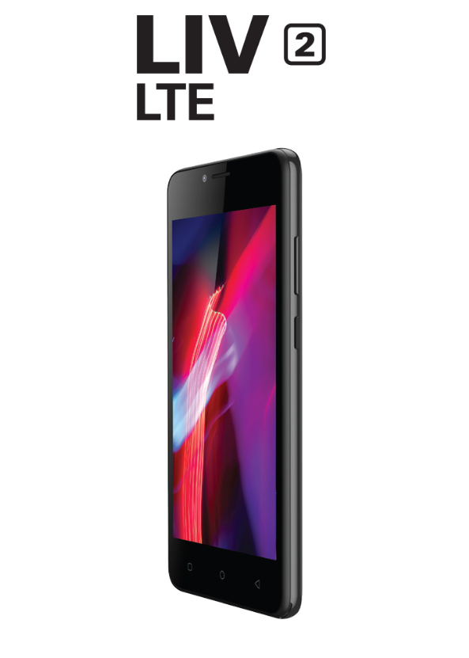

Content
FOR YOUR SAFETY 4
Important 5
Safety instructions 5
Rechargeable battery 5
Memory cards 6
Hearing protection 6
GET STARTED 7
Keys and parts 7
Screen 9
Icons 10
Insert the SIM card 10
Insert the memory card (optional) 11
FIRST START- UP 12
Switch the phone on 12
Switch the phone off 12
Restart the phone 12
Emergency 12
Charge your phone 13
Connect the headset 13
BASICS 14
Get to know your phone 14
Check notifications on your phone 14
Change the volume 14
Personalize your ringtone and other tones 14
Take a screenshot 14
Clock and calendar 15
Set an alarm 15
Add an appointment 15
Delete an appointment 15
CALL 15
Call a contact 15
Call a phone number 15
Call the last dallied number 16
Silence an incoming call 16
MESSAGES 16
CONTACTS 16
Create, edit, or delete a contact 16
Add a new contact 16
Edit a contact 16
Delete a contact 17
CAMERA 17
Camera basics 17
How to quickly open the camera 17
Take a photo 17
Camera tips 17
Record a video 18
GPS & NAVIGATION 18
See your current location 19
Download maps to your phone 19
PHONE MANAGEMENT & CONNECTIVITY 19
Use a Wi-Fi connection 19
Close the Wi-Fi connection 20
Use a mobile data connection 20
Manually add a mobile data access point 20
Share a mobile connection by hotspot 20
Backup 21
Restore your phone 22
ENTERTAINMENT 22
Listen to the radio 22
Go to the next or previous station 22
Save a radio station as a favourite 22
Copy music and videos from your PC 22
FCC CAUTION 23

FOR YOUR SAFETY

Read these simple guidelines. Not following them may be dangerous or against local laws and regulations.

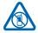
SWITCH OFF IN RESTRICTED AREAS
Switch the device off when mobile phone use is not allowed or when it may cause
interference or danger, for example, in aircraft, in hospitals or near medical
equipment, fuel, chemicals, or blasting areas. Obey all instructions in restricted areas.



ROAD SAFETY COMES FIRST
Obey all local laws. Always keep your hands free to operate the vehicle while driving.
our first consideration while driving should be road safety.


INTERFERENCE
All wireless devices may be susceptible to interference, which could affect
performance.



QUALIFIED SERVICE
Only qualified personnel may install or repair this product.


BATTERIES, CHARGERS, AND OTHER ACCESSORIES
Use only batteries, chargers, and other accessories approved by YEZZ Mobile for use
with this device. Third-party chargers that comply with the IEC/EN 62684 standard,
and that can connect to your device micro USB connector, may be compatible. Do
not connect incompatible products.


KEEP YOUR DEVICE DRY
Your device is not water-resistant. Keep it dry.


GLASS PARTS
The device screen is made of glass. This glass can break if the device is dropped on a
hard surface or receives a substantial impact. If the glass breaks, do not touch the
glass parts of the device or attempt to remove the broken glass from the device.
Stop using the device until the glass is replaced by qualified service personnel.


PROTECT YOUR HEARING
To prevent possible hearing damage, do not listen at high volume levels for long
periods. Exercise caution when holding your device near your ear while the
loudspeaker is in use.

Important

YEZZ mobile reserves the right to change products at any time without being obliged to adjust earlier supplies accordingly.

Do not make any adjustments and modifications that are not described in this manual. Follow all safety instructions to ensure proper operation of the device. The manufacturer assumes no liability for damages resulting from non-compliance with the safety instructions.

Safety instructions

- Protect the device from rain or water to prevent a short circuit.
- Do not expose the device to excessive heat caused by placing it on a heating device or in direct sunlight.
- Protect the cables from damage by being trapped, particularly at the plugs and where cables exit the housing.
- Back up your data and recordings. The manufacturer’s warranty does not cover loss of data resulting from user actions.
- Do not perform any maintenance operations that are not described in this user manual. Do not disassemble the device into its component parts to carry out repairs. The device may only be repaired in authorized service centers.

Rechargeable battery

If the battery is mishandled, it can burst, cause a fire or even chemical burns. Observe the following cautions.

- Do not disassemble.
- Do not crush and do not expose the battery pack to any shock or force such as hammering, dropping or stepping on it
- Do not short circuit and do not allow metal objects to come into contact with the battery terminals.
- Do not expose to high temperature above 60°C (140°F).• Do not incinerate or dispose of in fire.
- Do not handle damaged or leaking batteries.
- Keep the battery out of the reach of small children.
- Keep the battery dry.

Memory cards

The device operates with SD memory cards up to 64 GB in capacity.
YEZZ mobile uses approved industry standards for memory cards, but some brands may not be fully compatible with your device. Using an incompatible memory card may damage your device or the memory card and can corrupt data stored on the card.
Formatting a memory card erases all data on the card. Before formatting the memory card, make backup copies of all important data stored on the card. The manufacturer’s warranty does not cover loss of data resulting from user actions.
Formatting the memory card on a computer may cause incompatibilities with your device. Format the memory card only on the device.
EN

Hearing protection

- Set the volume to a moderate level and do not use head-phones to listen for excessively long periods of time.
- Be particularly careful to avoid adjusting the volume to a level that your hearing cannot deal with.
- Do not turn the volume up so high that you cannot hear what is going on around you.
- In potentially dangerous situations you must be very careful, or temporarily discontinue use.
- Do not use headphones while operating a motorized vehicle, cycling, or skateboarding, etc. You could be a hazard to your-self and other road users, and possibly be breaking the law.

GET STARTED

Congratulations on your purchase and welcome to YEZZ mobile!

To fully benefit from the service that YEZZ mobile offers, visit our Website for support information such as user manuals, new products, warranty information and more.

Overview

Keys and parts
Explore the keys and parts of your new phone.
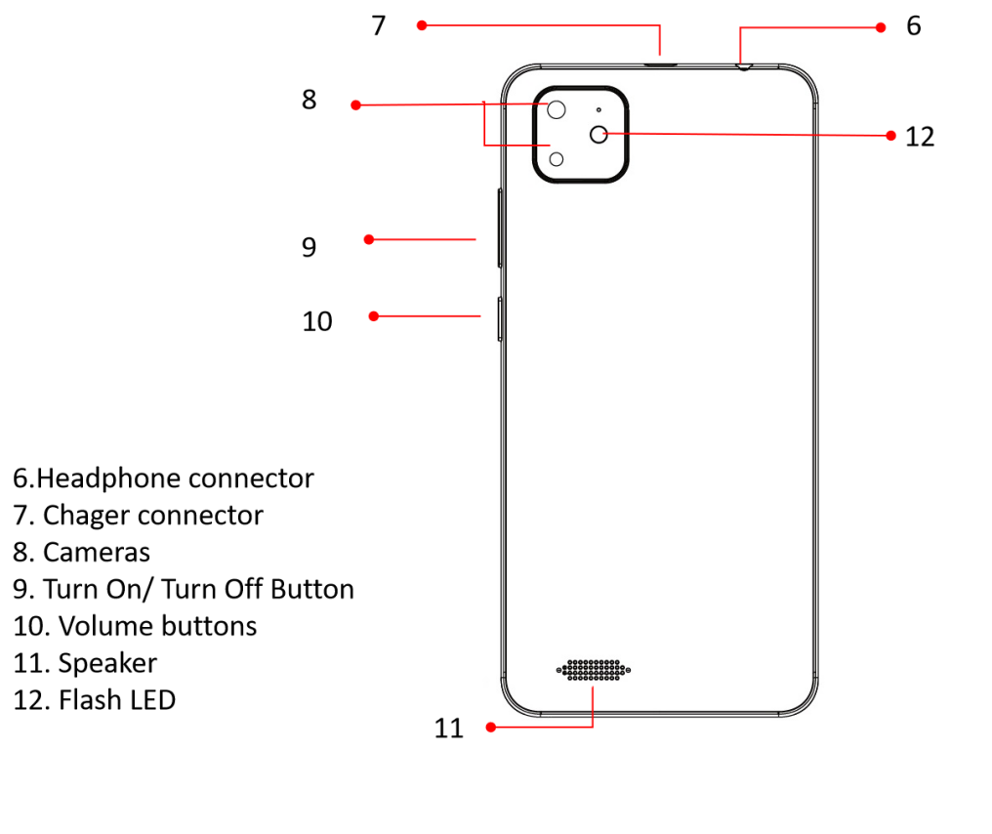
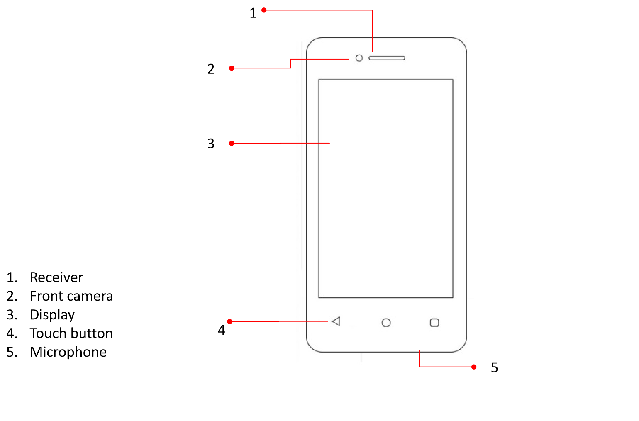

Key | Function
Power button | Allow you to turn on/off the device and to lock the screen.
Volume | Allow you to adjust the volume of ringing and notifications. Also allows you to adjust the volume of multimedia content playback.
Back | Allow you to return to the previous menu or screen. Also allow you to close some applications.
Home | It takes you directly to the home screen, leaving any application open.
Menu | Allow you to access to the functions menu of the application or screen you are.

Screen

The screen of your mobile phone is designed as follows:

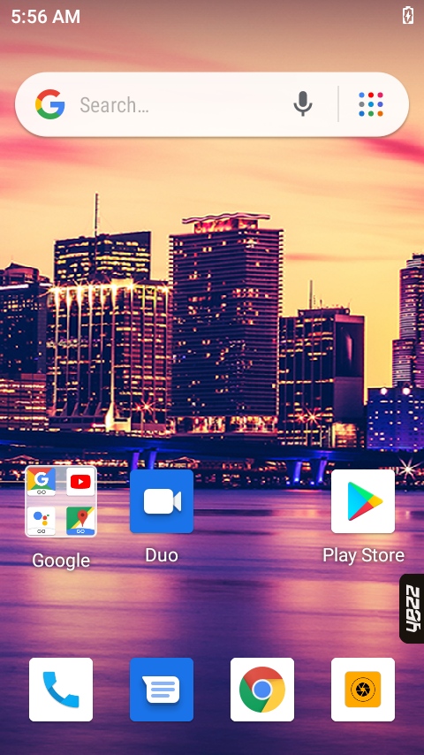

Icons
Learn about the icons that are displayed on the top of the screen, indicating the status of the phone.


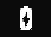
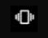


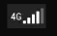
Signal strength Red WI-FI connection
Voice mail 2G connected
USB connected HSPA connected
Battery meter
Vibration profile LTE connected
Airplane mode Alarm set
Handset connected New message
Not Disturb New email

Insert the SIM card
Read on to learn how to insert your SIM card into your phone.
Important: Your device uses a nano-SIM card. Use only original nano-SIM cards. Use of incompatible SIM cards, or use of SIM card adapters, may damage the card or the device, and may corrupt data stored on the card.
Note: Switch the device off and disconnect the charger and any other device before removing any covers. Avoid touching electronic components while changing any covers. Always store and use the device with any covers attached
Make sure your phone is switched off.

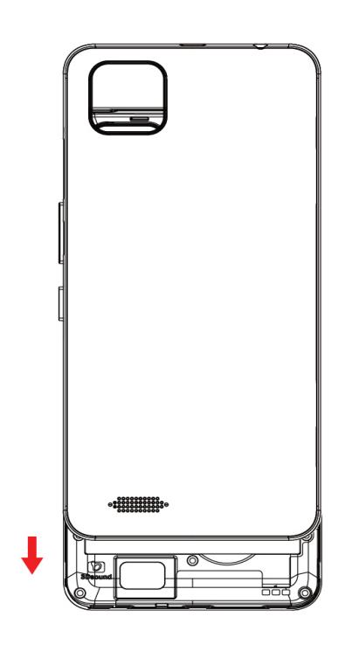
- At the down corner of your phone, put the nail of your thumb finger in the seam between the screen frame and the back cover. Press the middle of the back cover, and bend the cover to loosen the top hooks. Remove the cover.

Do not use any sharp tools,
as they may damage the screen.

- If the battery is installed, remove it.
- Push the SIM into the SIM slot until it is fully inserted. Make sure the contact area is
facing down. Your phone has 2 SIM card slots to allow you use 2 SIM cards and switch
between them.

On a dual SIM card device, you can set the default SIM cards for make calls, SMS messages and use mobile data in Settings> Network & internet > SIM cards> Select the SIM card of your choice for mobile data, calls and SMS messages.

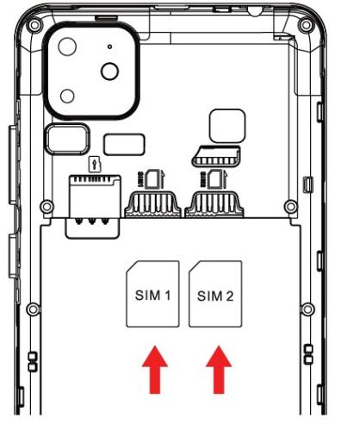

Note: Without inserting a SIM card, you can use your phone’s non-network services and some menus.

- Line up the battery contacts, and replace the battery.
- Press the back of the cover until it snaps into place.

Insert the memory card (optional)

Learn how to insert your memory card into your phone.

Use only compatible memory cards approved for use with this device. Incompatible cards may damage the card and the device and corrupt data stored on the card.


Formatting the memory card on a computer may cause incompatibilities with your
device. Format the memory card only on the device.

Your phone supports memory cards with a capacity of up to 64 GB.Make sure your phone is switched off.

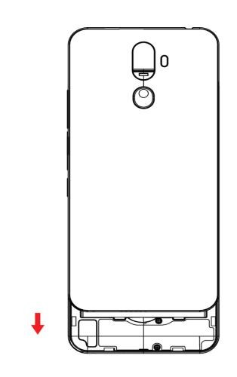
- At the down corner of your phone, put the nail of your thumb finger in the seam between the screen frame and the back cover. Press the middle of the back cover, and bend the cover to loosen the top hooks. Remove the back cover.

Do not use any sharp tools,
as they may damage the screen.

- If the battery is installed, remove it.
- Push the memory card into the memory card slot until it locks into place.

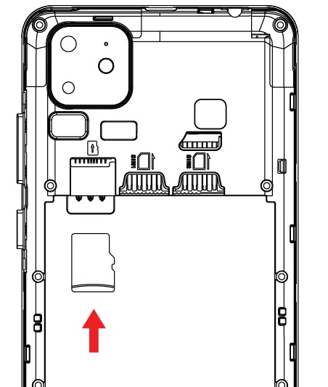

- Line up the battery contacts, and replace the battery.
- Press the back of the cover until it snaps into place

FIRST START- UP

Learn how to get your new phone up and running.

Your new phone comes with great features that will be installed when you start your phone for the first time. Allow some minutes for you phone to be ready.

Switch the phone on

Are you ready? Switch your phone on, and start exploring it.

Long press the power button. Type in your PIN number (if it is needed).

Switch the phone off

Press and hold the power button to open the device options dialog. Tap “Power Off” in the dialog window. The device will shut down.

Restart the phone

Press and hold the power button to open the device options dialog. Tap "Restart" in the dialog window. The device will reboot.

Emergency

Press and hold the power button to open the device options dialog. Tap "Emergency" in the dialog window. You can dial the emergency number of your country.

Charge your phone

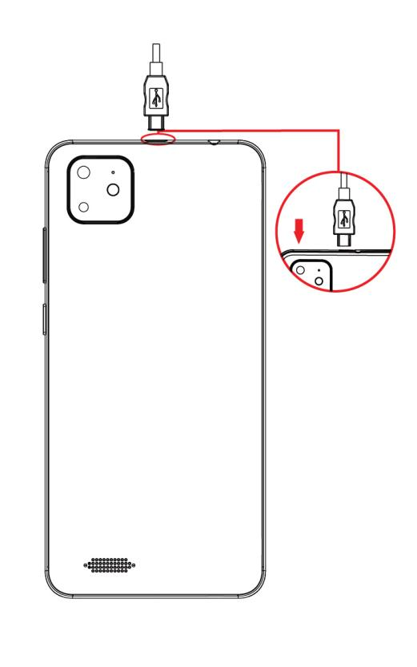
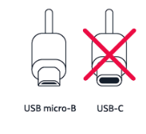
Your battery has been partially charged at the factory, but you may need to recharge it before you can switch the phone on for the first time. Make sure you use a compatible USB charger to charge your phone.

- Connect the USB cable to the charger and plug the charger into a wall outlet.
- Connect the Type C- USB end of the charger's cable to your phone.
- When the battery is full, disconnect the charger from the phone, then from the wall outlet.

Don’t use incompatible/unauthorized chargers. If the battery is charged
under unacceptable conditions (for example: usage in restricted temperature
ranges, over voltage, or over current with unauthorized chargers), the battery
may catch on fire, smoke, explode, or cause heat generation.

Connect the headset

Enjoy your favorite music, you use headset as an antenna to operate the FM radio application, or free your hands for other things during a call. Connect the headset to your phone.

BASICS

Learn how to get the most out of your new phone.

Get to know your phone

Your phone has two views, the home screen and the application menu. To see the application menu, just swipe from bottom to top.

Check notifications on your phone

Want to check your latest mails or messages quickly? Or to connect to a WiFi network easily? You can quickly check notifications, change some settings and more, in the notification panel that opens from the top of the screen.

Swipe down from the top of the screen.

In this screen, you can:

- See your missed calls and recent unread mails and messages
- Check any notifications, such as available app updates in Play Store
- Open apps
- Check for WiFi networks, and connect to them
- Quickly jump to settings

To close the menu, press the back key.

Change the volume

If you have trouble hearing your phone ringing in noisy environments, or calls are too loud, you can change the volume to your liking.

Personalize your ringtone and other tones

Want to change the notification tones your phone uses, for example, for calls, messages, and more? You can personalize your phone tones.

Go to Settings > Sound > Select the type of ringtone or alert you want to change, and select the sound.

Take a screenshot

You can take screenshots of what’s on your phone screen.

- Press the volume down key and the power key at the same time.
- To view or manage the screenshots you’ve taken, go to Files > Images > Screenshots.

From the device option dialog you can take a screenshot.

- Press and hold the power button to open the device options dialog. Tap "Screenshot" in the dialog window. The device will take the screenshot.

Clock and calendar
Keep track of time – learn how to use your phone as a clock, as well as an alarm clock, stopwatch, timer and how to keep your appointments, tasks, and schedules up to date.

Set an alarm
You can use your phone as an alarm clock.

Go to Clock > alarm > Set the time, fill in the alarm details, and tap OK.
Tip: By default, when the alarm sounds, you can snooze the alarm when you
press the volume buttons.

Add an appointment

Need to remember an appointment? Add it to your calendar.

Tap Calenda app > Touch select the type of event to add > Type in the details you want, and set the time

Tip: To edit an event, tap and hold the event you want, tap edit, and edit the
details you want.

Delete an appointment

Tap and hold the appointment, and tap delete.

CALL

Learn to make or answer calls in this section.

Call a contact

Calling your friends is quick and easy when you've saved them as contacts in your phone.
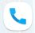
On the start screen, select > and Tap the contact and the number, if the contact has several numbers.

T Tip:Press the volume key to change the volume of the call.

Tip: Want to let others hear the conversation? Tap speaker.

Call a phone number

On the start screen, select > Tap , type in the phone number, and tap call icon.To type in the + character, used for international calls, tap and hold 0.

Call the last dallied number

Trying to call someone, but they are not answering? It is easy to call them again. In the call history view, you can see information about the calls you have made and received.

Silence an incoming call

When someone calls you, press the volume key or power off key.

MESSAGES

You can send and receive different kinds of messages:

- Text messages
- Multimedia messages that contain your pictures

Messages and chats between you and a particular contact are arranged into conversation.

You can send text messages that are longer than the character limit for a single message. Longer messages are sent as two or more messages. Your service provider may charge accordingly.

Characters with accents, other marks, or some language options, take more space,limiting the number of characters that can be sent in a single message.


Select and after Start chat > Type in the phone number or contact name on the field or touch to access to Contacts > Type in your message >Touch to send the message.

CONTACTS
You can save and organize your friends' phone numbers, addresses, and other contact information in the phonebook feature.

Create, edit, or delete a contact

Add a new contact

Touch Contacts then touch on the bottom to add a new
contact.

Fill the contact information (Name, Last name and phone number). You can add more fields such as, email, address.

Save the added contact.

Edit a contact

Select the contact and

If the contact has several accounts linked in the contact card,
select an account.

Select a contact detail, edit the fields, and select .

Delete a contact
Select the contact and > delete.If the contact has several accounts linked in the contact card, select an account and delete.The contact is deleted both from your phone and, with some exceptions, from the online service where it's stored.

CAMERA
With your phone camera, you can easily take photos or record videos.

Camera basics

Taking a photo or recording a video is quick and easy, as is sharing it with your friends.

How to quickly open the camera

- Access shortcuts of the camera.

Double-click Power button to launch the camera app.

Take a photo

Shoot sharp and vibrant photos – capture the best moments in your photo albu.


Tap Camera.

Touch the shot button on the screen to capture the picture. It will be saved automatically.

Camera tips

Here are some tips to help you get the most out of your phone camera.

- To zoom in or out, pinch your fingers outward. This motion is basically the opposite of a pinch. Start by your thumb and pointer finger together on the screen, then move them away from one another in opposite directions. As you move your fingers, the image on the screen will grow larger.
- Do not cover the flash while taking a photo.
- Keep a safe distance when using the flash. Do not use the flash on people or animals at close range.
- To activate flash, tap the flash icon on the screen. Toggle the lighting icon to the desired setting:


Lightning with nothing: Flash will activate on every picture.


Lightning with slash: Flash is disabled.


Lightning with A = Auto-detect flash.

Record a video
Besides taking pictures with your phone, you can also capture your special moments as videos.

- To open the camera, press the camera key.
- To switch from image mode to video mode, select 
- To start recording, press the camera key. The timer starts to run.
- To stop recording, press the camera key. The timer stops.

GPS & NAVIGATION

Your phone shows your location on the map using GPS, A-GPS, Wi-Fi, or cellular positioning.

GPS | The global positioning system (GPS) is a navigation system thatuses satellites to work out where you are.
A-GPS | The Assisted GPS (A-GPS) network service retrieves location information using the cellular network, and assists GPS in calculating your current location.
Wi-Fi | Wi-Fi positioning improves positioning accuracy when GPS signals are not available, especially when you are indoors or between tall buildings.You can also switch Wi-Fi and cellular positioning off in your phonesettings.
Cell ID | With network (cell ID) based positioning, your phone locates you through the cellular system your phone is currently connected to.

Maps helps you find specific locations and businesses.
Tap  maps.
Write search words, such as a street address or place name, in the search box.
Select an item from the list of proposed matches as you write, or tap the enter key to search.The location is shown on the map.
If no search results are found, make sure the spelling of your search words is correct.

See your current location
Tap

Download maps to your phone
Save new maps to your phone before a journey, so you can browse the maps without an internet connection when travelling.
To download and update maps, switch Wi-Fi networking on.
Go to Maps > Offline maps > Select your own map (country or region) > Download.

PHONE MANAGEMENT & CONNECTIVITY
Take care of your phone and its content. Learn how to connect to accessories and networks, transfer files, create backups, lock your phone, and surf the Internet.

Use a Wi-Fi connection
If your network service provider charges you on a pay-as-you-use basis, you may want to change the WiFi and mobile data settings to reduce your data costs.

Go to settings.

Select Network & internet > Wi-Fi.

Make sure WiFi networking is switched to On Select the connection you want to use.

Using a Wi-Fi connection is generally faster and less expensive than using a mobile data connection. If both Wi-Fi and mobile data connections are available, your phone uses the Wi-Fi connection.

Close the Wi-Fi connection
Switch WiFi networking to Off

Use a mobile data connection

- Select Network & internet > Mobile network.
- Switch Mobile data to On

Manually add a mobile data access point

- Select Network & internet > Mobile network > Advanced > Access point names > Select to add APN.

- Write the APN address in the APN field.
- Type in the username and password for your mobile data account.
- If the APN uses a proxy server, write the address and port number in the appropriate fields.
- When you finish typing in the parameters needed, touch menu
- Then Save.

Share a mobile connection by hotspot
You can use your phone's mobile data to connect another phone, tablet, or computer to the internet. Sharing a connection this way is called tethering or using a hotspot.

Turn on your hotspot
1. Select Network & internet > Hotspot & tethering > Wi-Fi hotspot > Switch Wi-Fi hotspot to On

About the web browser
Select
Catch up on the news, and visit your favourite websites. You can use Chome Mobile in your phone to view web pages on the internet.

To browse the web, you must be connected to the internet.

Bluetooth
You can connect wirelessly to other compatible devices, such as phones, computers, headsets, and car kits. You can also send your photos to compatible phones or to your computer

Paired devices can connect to your phone when Bluetooth is switched on. Other devices can detect your phone only if the Bluetooth settings view is open. Do not pair with or accept connection requests from an unknown device. This helps to protect your phone from harmful content.

Connect to a wireless headset

With a wireless headset, you can speak on the phone hands free – you can continue what you were doing, such as working at your computer, during a call. Make sure the headphones are compatible with your phone.

Go to settings.
- Select Connected devices > Pair new device
- Make sure that the accessory you want to pair is on.
- To pair your phone and the headset, select the headset from the list.

For details, see the user guide of the headset.

Connect to your friend’s phone with Bluetooth

Use Bluetooth to wirelessly connect to your friend's phone, to share photos and much more.

Go to settings.

- Select Connected devices > Pair new device.
- Make sure Bluetooth is switched on in both phones.
- Make sure both phones are visible to other phones. You need to be in the Bluetooth settings view for your phone to be visible to other phones.
- You can see the Bluetooth phones within range. Tap the phone you want to connect to.
- If the other phone needs a passcode, type in or accept the passcode.
- The passcode is only used when you connect to something for the first time.

Back up and restore your phone

You can back up content, data, and settings from your phone to your Google Account. You can restore your backed-up information to the original phone or to some other Android phones.

Backup

- Open your phone's Settings app. 2.Tap System > Advanced > Backup.
- Tap Account to add it.
- If needed, enter your phone's PIN, pattern, or password.
- Sign in to the account that you want to add.

Restore your phone

- Open your phone's Settings app.
- Tap System > Advanced > Reset option
- Tap on Erase all data (Factory Reset)
- Tap on Erase all data.

ENTERTAINMENT

Listen to the radio

Enjoy your favourite FM radio stations on the go.

Connect a compatible headset, then enter to FM radio from your phone. The headset acts as an antenna.

Go to the next or previous station

Swipe left or right..

Tip: If you use a shorter swiping motion, you can skip to stations that have a stronger
signal.

Save a radio station as a favourite

Save your favourite radio stations so you can easily listen to them later.
To save the station that you are listening to, select

Copy music and videos from your PC

Do you have media on your PC that you want to listen to or watch on your phone?

- Use a compatible USB data cable to connect your phone to a compatible computer.
- On your computer, open the phone's folder.
- Transfer the files to your phone.

Download a game, app, or other item

Download free games, apps, or videos, or buy more content for your phone. From Play store, you can find content designed specifically for your phone.
Select 
Make sure your battery is fully charged before starting a download.

- Select the item.
- If the item has a price, select buy. If the item is free, select install.
- If you're not signed in to gmail, sign in now.
- Follow the instructions shown on the phone.

FCC CAUTION

Any Changes or modifications not expressly approved by the party responsible for compliance could void the user's authority to operate the equipment.

Before a new model phone is available for sale to the public, it must be tested and certified to the FCC that it does not exceed the exposure limit established by the FCC, Tests for each phone are performed in positions and locations (e.g. at the ear and worn on the body) as required by the FCC.

This device complies with part 15 of the FCC Rules. Operation is subject to the following two conditions: (1) This device may not cause harmful interference, and (2) this device must accept any interference received, including interference that may cause undesired operation.

Note: This equipment has been tested and found to comply with the limits for a Class B digital device, pursuant to part 15 of the FCC Rules. These limits are designed to provide reasonable protection against harmful interference in a residential installation.

This equipment generates, uses and can radiate radio frequency energy and, if not installed and used in accordance with the instructions, may cause harmful interference to radio communications. However, there is no guarantee that interference will not occur in a particular installation. If this equipment does cause harmful interference to radio or television reception, which can be determined by turning the equipment off and on, the user is encouraged to try to correct the interference by one or more of the following measures:

- Reorient or relocate the receiving antenna.
- Increase the separation between the equipment and receiver.
- Connect the equipment into an outlet on a circuit different from that to which the receiver is connected.
- Consult the dealer or an experienced radio/TV technician for help.

