

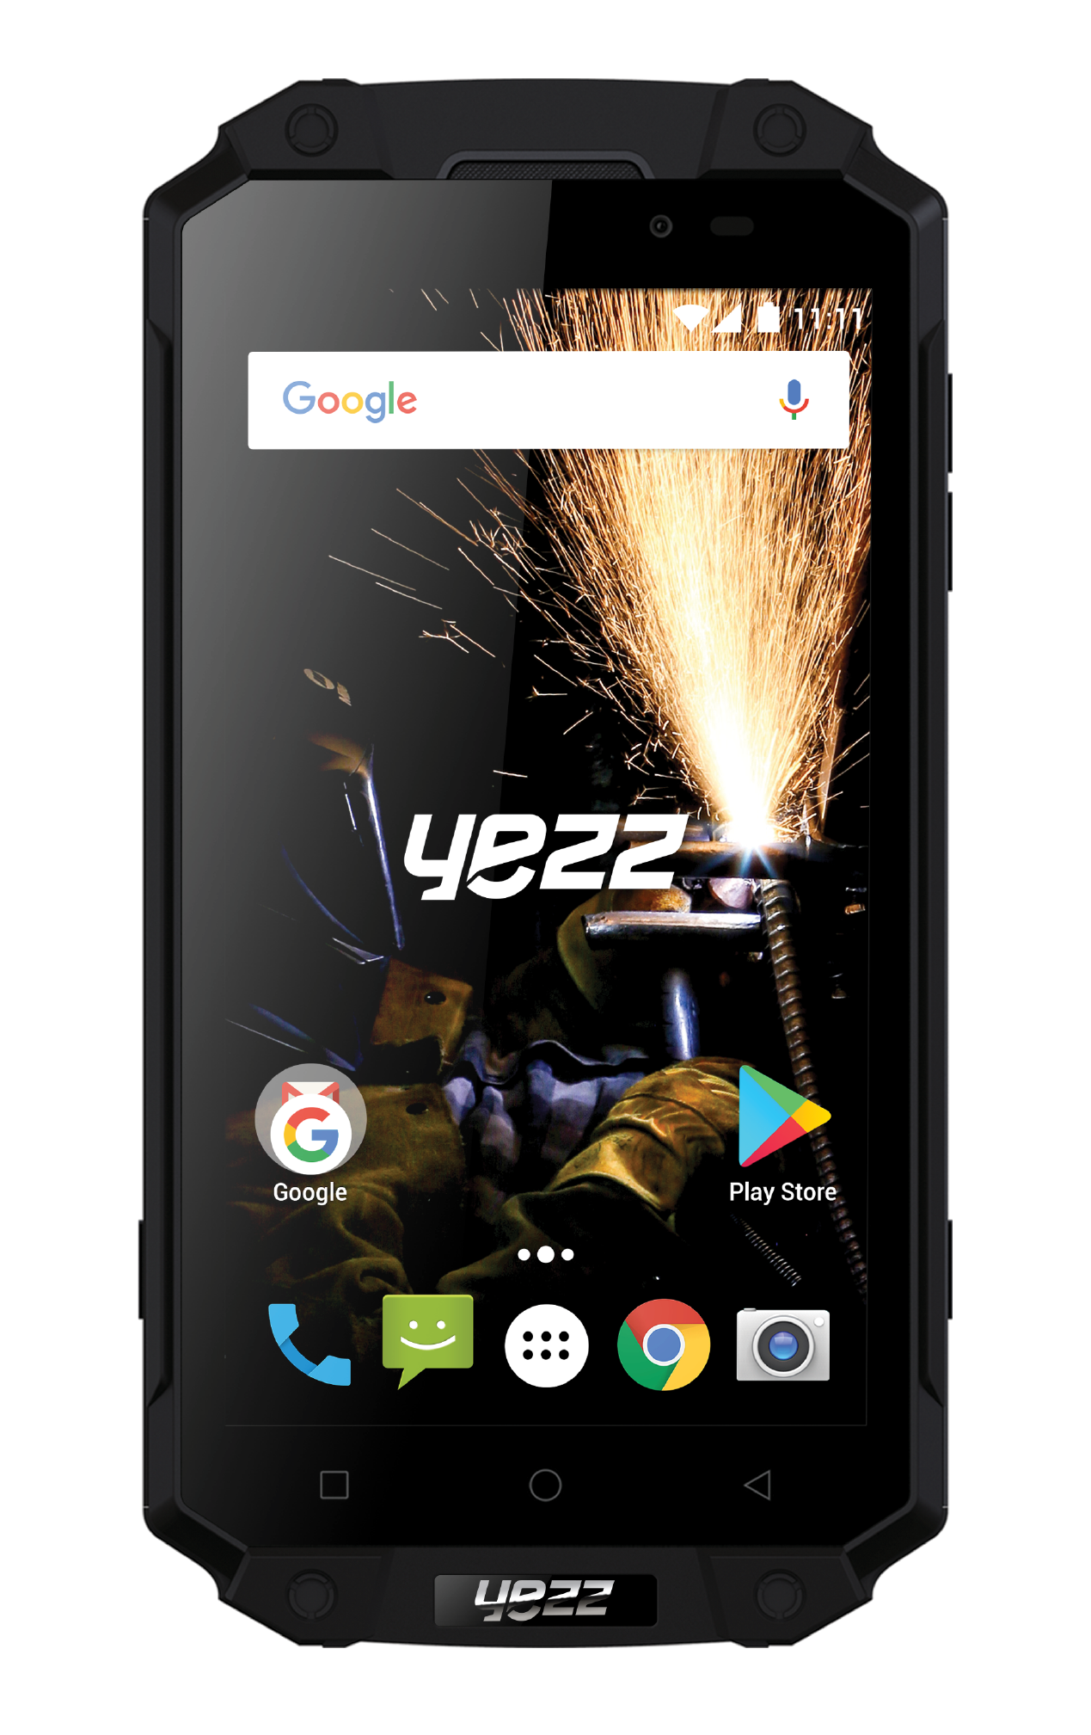
TABLE OF CONTENTS

SECURITY INFORMATION 4
INTRODUCING YOUR MOBILE PHONE 8
Phone layout 8
Keys 10
Screen 11
Icons 12
STARTING YOUR MOBILE PHONE 13
To install the SIM card 14
To install the SD card (optional) 15
USING BASIC FUNCTIONS 16
Turn your phone on and off 16
Access menus and applications 16
Use basic call functions 17
Make a call 17
To answer a call 17
Send and view messages 17
Steps to send Text and Multimedia Messages: 17
Add contacts 18
Add a new contact 18
Search for a contact 19
Listen to FM radio 19
Browse the web 19
USING THE CAMERA 20
Capture pictures 20
CONNECTING TO INTERNET 21
Add a new connection 21
Switch between carriers 22
(SIM cards) 22
USING THE Wi-Fi 23
Connect to a wireless network 23
Disconnect from a wireless network 23
View the technical details of a wireless network 24
SAR 25
FCC 27

SECURITY INFORMATION

Please remember to obey relevant rules and regulations whenever use your phone. This will prevent bad effect from you and the environment.

v.2018.03.28

General security

 | When driving, riding your bike or walking, do not use headphones or earphones. Your attention could be diverted, which may cause an accident and be against the law in certain geographical areas. For safety precautions do not use your phone while driving, always stay aware of your surroundings. Follow all safety instructions and regulations relating to the use of your device when you are driving a vehicle.
 | Don’t use at petrol stations.
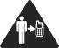 | Keep your phone at least 15 mm away from your ear or body while making calls.
 | Your phone may produce a bright or flashing light.
 | Small parts may cause a choking.
 | Don’t dispose of your phone in fire.
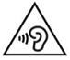 | To avoid any hearing damage, do not listen to high volume levels for an extended. Excessive sound pressure from earphones and headphones can cause hearing loss.
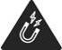 | Avoid contact with anything magnetic.
 | Keep away from pacemakers and other electronic medical devices.
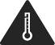 | Avoid extreme temperatures.
 | Switch off when asked to in hospitals and medical facilities.
 | Avoid contact with liquids. Keep your phone dry.
 | Switch off when told to in aircrafts and airports.
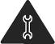 | Don’t take your phone apart.
 | Switch off when near explosive materials or liquids.
 | Only use approved accessories.
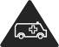 | Don’t rely on your phone for emergency communications.

Look at the adapter regularly, specifically at the plug and the layer to detect any damages. If the adapter is damaged, you can’t use it until it’s fixed.

Plug in the adapter to a power outlet which is easily accessible. Always unplug the adapter after using it.

Use only the adapter provided with the device.

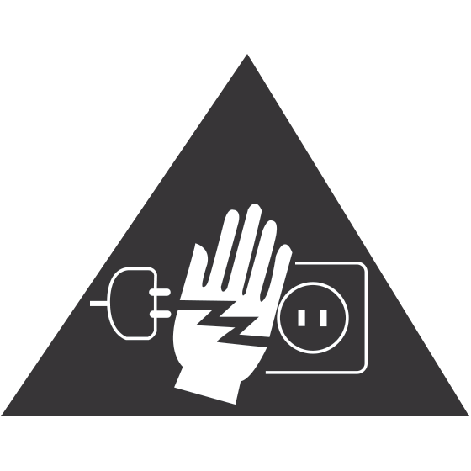 | Warning electrical hazard  To avoid serious injury, do not touch the plug of the charger!  Disconnect the charger when you do not use it.  To disconnect a charger or an accessory, pull the plug, not the power cable.  The power module is the element that allows you to disconnect the product.  The power plug must stay easily accessible.

Do not expose your device to direct sunlight, like on your car’s dashboard, for example.

In case of overheating do not use the device.

Be careful when using the device while walking.

Do not subject the device to severe impact or drop it from high position, it could cause damages or malfunctions.

Do not disassemble, modify or fix the device by yourself.

To clean the device use a clean and soft rag.
Do not use any chemical product or detergent.

INTRODUCING YOUR MOBILE PHONE

Learn about your mobile phone’s layout, keys, display and icons.

Phone layout

From the front view of your phone you will observe the following elements:

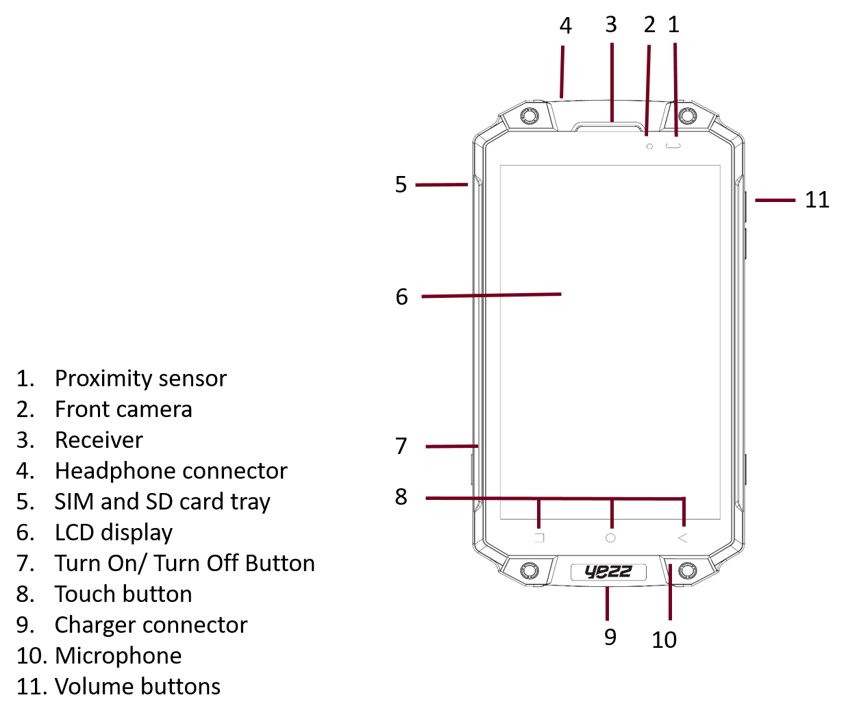

From the back view of your phone you will observe the following elements:

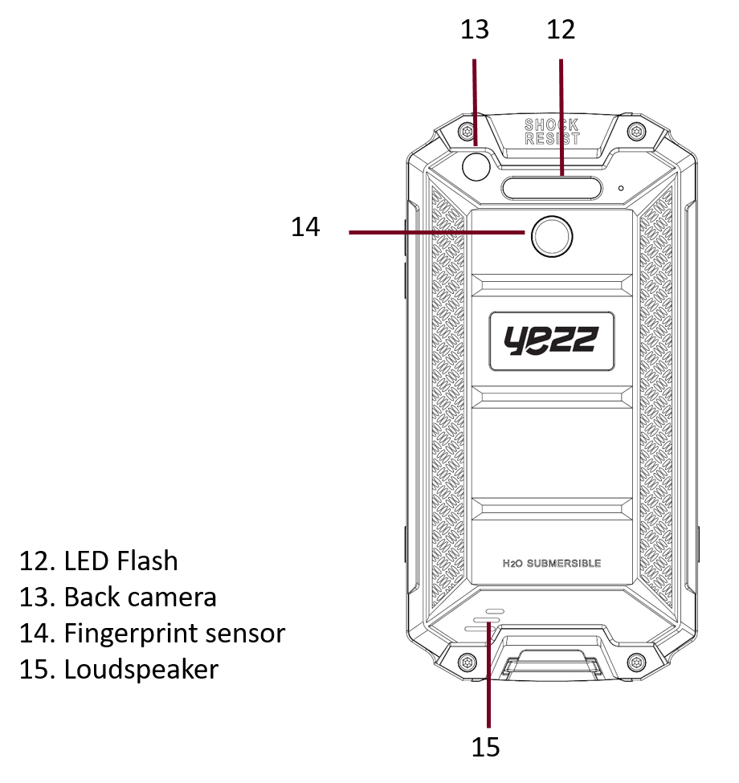

Keys

The following table offers you a quick description about the phone’s keys:

Key | Function
Power button | Allow you to turn on/off the device and to lock the screen.
Volume | Allow you to adjust the volume of ringing and notifications. Also allows you to adjust the volume of multimedia content playback.
Back | Allow you to return to the previous menu or screen. Also allow you to close some applications.
Home | It takes you directly to the home screen, leaving any application open.
Menu | Allow you to access to the functions menu of the application or screen you are.

Screen

The screen of your mobile phone is designed as follows:

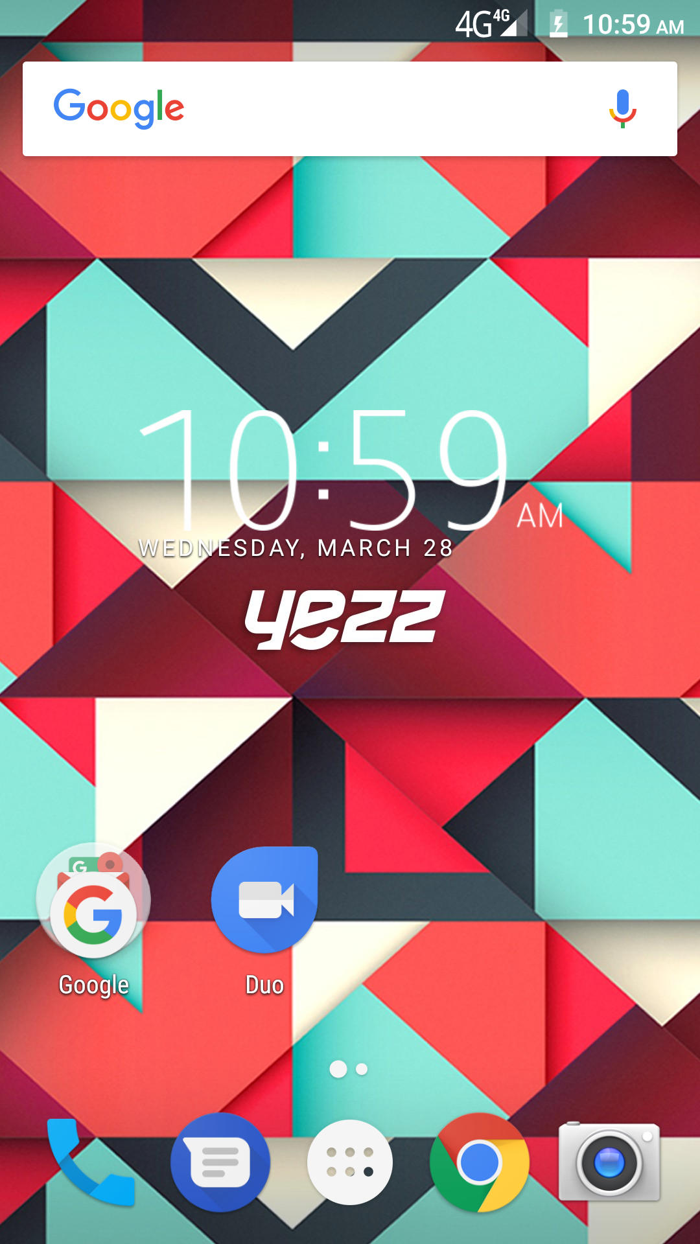

Icons

Learn about the icons that are displayed on the top of the screen, indicating the status of the phone:

 | Signal strength |  | Red WI-FI connection
 | Voice mail |  | 2G connected
 | USB connected |  | HSPA connected
 | Battery meter |  | LTE connected
 | Vibration profile |  | New message
 | Airplane mode |  | New email
 | Handset connected |  | Alarm set

STARTING YOUR MOBILE PHONE

Get started setting up your mobile phone for its first use

Remove the tray in the lateral side.

- Make sure that the device is OFF.
- Use the slot to remove the tray and pull softly.
- The tray will be pop, remove the tray of the SIM card and SD card.

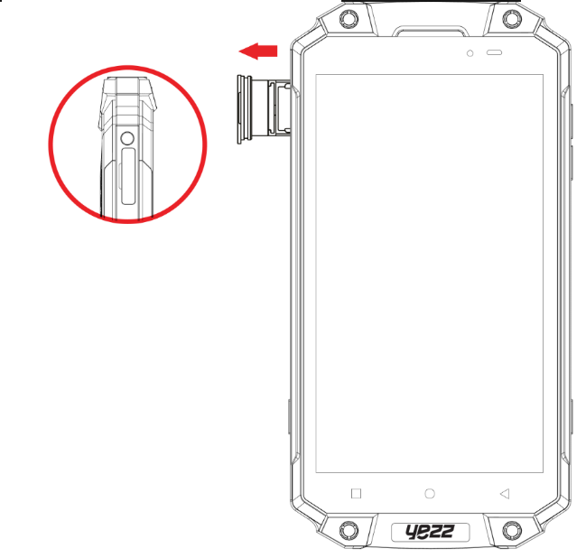

To install the SIM card

When you subscribe to a cellular service, you will receive a Subscriber Identity Module (SIM) card, with subscription details, such as your personal identification number (PIN) and optional services.

1. Locate the slot of the SIM card, please make sure that the corner of the SIM card match with the corner the slot.

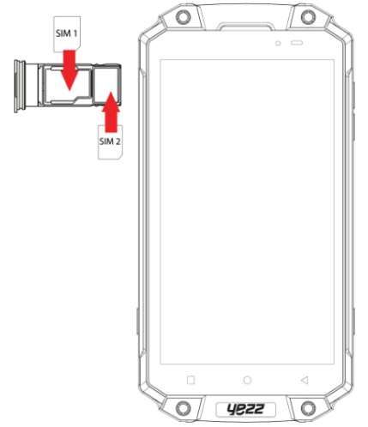

Your phone has 2 SIM card slots to allow you use 2 SIM cards and switch between them.

To install the SD card (optional)

To store additional multimedia files, you must insert a memory card.

- Formatting the memory card on a PC may cause incompatibility with your phone. Format the memory card only on the phone.

1. Locate the slot of the SD card, please make sure that the shape of the SD card match with the shape of the slot.

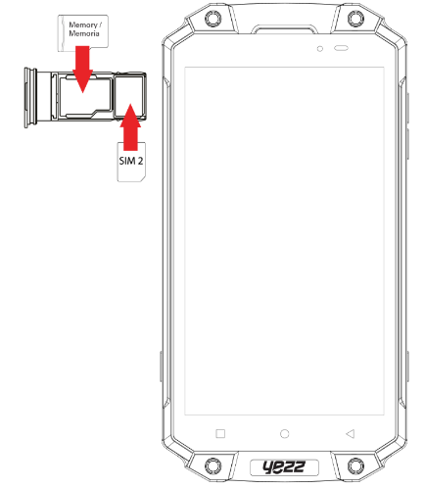

USING BASIC FUNCTIONS

Learn how to perform basic operations of your mobile phone.

Turn your phone on and off

To turn your phone on,

1. Long press the power button.

2. Type in your PIN number and press OK (if it is needed).

To shut down your phone, go to step 1 above.

Access menus and applications

To get access to the Menu and Applications,

1. At the home screen, touch the button  on the screen to pop up the list of Installed Applications in your phone.

2. Slide your finger to the right or left to access other pages of apps.

3. Touch any icon to enter to the application.

4. To exit the application, press Back or Home at the bottom of the screen.

Use basic call functions

Learn to make or answer calls in this section.

Make a call:

1. At the home screen or applications menu, touch the Phone icon 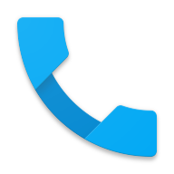 .

2. Dial the area code and phone number.

3. Touch  to start the call.

4. To end a call, touch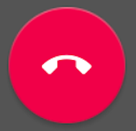.

To answer a call:

1. When you receive a call, slide the phone icon to the right to answer it or slide it to the left to reject it 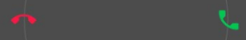 .

2. To end the call, touch.

Send and view messages

In this section, learn how to send and receive:

- Text Messages (SMS).

- Multimedia Message (MMS).

Steps to send Text and Multimedia Messages:

1. Touch  Messages at the application list, then touch  on the corner.

2. Type in the phone number  or contact name on the field or touch to access to Contacts.

3. Type in your message.

To send as text message go to step 5.

To attach a multimedia object (audio, image, etc.) continue to step 4.

4. Touch  on the down left corner, select the attach type then choose the item.

5. Touch  to send the message.

Add contacts

Learn the basics of using the phonebook feature.

Add a new contact:

1. In the application list touch Contacts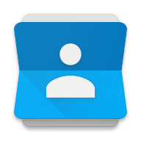, then touch  on the bottom to add a new contact.

2. Fill the contact information (Name, Last name and phone number). You can add more fields such as, email, address.
3. Touch on the top of the screen to save.

Search for a contact

1. In the application list touch Contacts.

2. Slide your finger from bottom to top to scroll the list or touch the search button  and type in the first letters of the name or last name.

3. To see the contact details touch the name or the picture of the contact.

If you want to call a contact touch the phone number.

Listen to FM radio

Learn how to listen FM radio.

1. Plug in the earphones in your phone.

2. In the application list touch 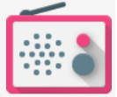 FM Radio.

3. Use the tool bar at the bottom to change of station.

Browse the web

Learn how to access to your favorites Web Sites.

1. In the application list, select Chrome app.

2. Touch the address bar and type in the address of the web site you want to go.

USING THE CAMERA

Learn the basics to capture and view photos.

Capture pictures

1. In the applications list, touch  Camera.

2. Adjusts the lens at the photo target and make the desired adjustments by touching the settings button.

3. Touch the shot button  on the screen to capture the picture. It will be saved automatically.

See the captured pictures

In the camera app, on the down right corner touch the last image taken and then select  to access and visualize all the pictures captured by your phone.

CONNECTING TO INTERNET

Learn the basics to configure your phone and connect to Internet.

Add a new connection

1. In the applications list, touch  Settings to access to the device configuration.

2. Touch the option “More…”, then touch Mobile networks and touch Access Point Names. Now select the SIM Card that you want to configure.

3. Touch the Menu key and select New APN then, type in the parameters according with your Carrier.

The basic parameters are:

- Name
- APN
- Username
- Password

Some carriers use Proxy Servers, refer to your carrier configuration for more information.

4. When you finish typing in the parameters needed, touch Menu  then Save.

If you have multiples APN Configurations for the same SIM card, choose which one you want to use touching the radio button  at the right side of the name.

To add another connection, repeat from step 3.

Switch between carriers (SIM cards)

If you use multiple SIM cards and want to switch to another one, follow these steps:

1. In the applications list, touch Settings to access to the device configuration.

2. Touch.

3. Choose the option Data connection and select the SIM Card that you want to use.

USING THE Wi-Fi

Learn to use the phone's wireless capabilities to connect to any wireless local area network compatible.

Connect to a wireless network

1. In the applications list, touch Settings to access to the device configuration.

2. Touch the Wi-Fi option.

3. To turn the On the Wi-Fi touching the button  on the right top corner.

4. Choose a wireless network and enter the security password if it is needed.

Disconnect from a wireless network

1. In the applications list, touch Settings to access to the device configuration.

2. Touch the Wi-Fi option.

3. To turn the Wi-Fi off touch the button  on the right top corner.

View the technical details of a wireless network

1. In the applications list, touch Settings to access to the device configuration.

2. Touch the Wi-Fi option.

3. Touch the active wireless network to see details such as Link Speed, Signal strength and more.

SAR

Please take time to read this important section.

RADIO WAVES

Proof of compliance whit international standards (ICNIRP) or with European Directive 1999/5/EC (R&TTE) is required of all mobile phone models before they can be put on the market. The protection of the health and safety for the user any other person is an essential requirement of these standards or this directive.

THIS DEVICE MEETS INTERNATIONAL GUIDELINES FOR EXPOSURE TO RADIO WAVES

Your mobile device is a radio transmitter and receiver. It is designed not to exceed the limits for exposure to radio waves (radio frequency electromagnetic fields) recommended by international guidelines. The guidelines were developed by an independent scientific organization (ICNIRP) and include a substantial safety margin designed to assure the safety of all persons, regardless of age and health.

The radio wave exposure guidelines use a unit of measurement known as the Specific Absorption Rate, or SAR. The SAR limit for mobile devices is 2 W/kg.

Tests for SAR are conducted using standard operating positions with the device transmitting at its highest certified power level in all tested frequency bands.

Body-worn SAR testing has been carried out at a separation distance of 1.0 cm. to meet RF exposure guidelines during body-worn operation, the device should be positioned at least this distance away from the body. If you are not using an approved accessory ensure that whatever product is used is free of any metal and that it positions the phone the indicated distance away from the body.

For more information you can go to www.sayyezz.com

Additional information about electromagnetic fields and public health are available on the following site. http://www.who.int/peh-emf.

Your telephone is equipped whit a built-in antenna. For optimal operation, you should avoid touching it or degrading it.

As mobile devices offer a range of functions, they can be used in positions other that against your ear. In such circumstances the device will be compliant whit the guidelines when used with headset or USB data cable. If you are using another accessory ensure that whatever product is used is free of any metal and that it positions the phone at least 1.0 cm away from the body.

FCC

Please take time to read this important section.

FCC Caution

Any Changes or modifications not expressly approved by the party responsible for compliance could void the user's authority to operate the equipment.

Before a new model phone is available for sale to the public, it must be tested and certified to the FCC that it does not exceed the exposure limit established by the FCC, Tests for each phone are performed in positions and locations (e.g. at the ear and worn on the body) as required by the FCC.

This device complies with part 15 of the FCC Rules. Operation is subject to the following two conditions: (1) This device may not cause harmful interference, and (2) this device must accept any interference received, including interference that may cause undesired operation.

Note: This equipment has been tested and found to comply with the limits for a Class B digital device, pursuant to part 15 of the FCC Rules. These limits are designed to provide reasonable protection against harmful interference in a residential installation.

This equipment generates, uses and can radiate radio frequency energy and, if not installed and used in accordance with the instructions, may cause harmful interference to radio communications. However, there is no guarantee that interference will not occur in a particular installation. If this equipment does cause harmful interference to radio or television reception, which can be determined by turning the equipment off and on, the user is encouraged to try to correct the interference by one or more of the following measures:

- Reorient or relocate the receiving antenna.

- Increase the separation between the equipment and receiver.

- Connect the equipment into an outlet on a circuit different from that to which the receiver is connected.

- Consult the dealer or an experienced radio/TV technician for help.

