INTRODUCING YOUR MOBILE PHONE

Learn about your mobile phone’s layout, keys, display and icons.

v.2017.02.07

Phone layout

From the front view of your phone you will observe the following elements:

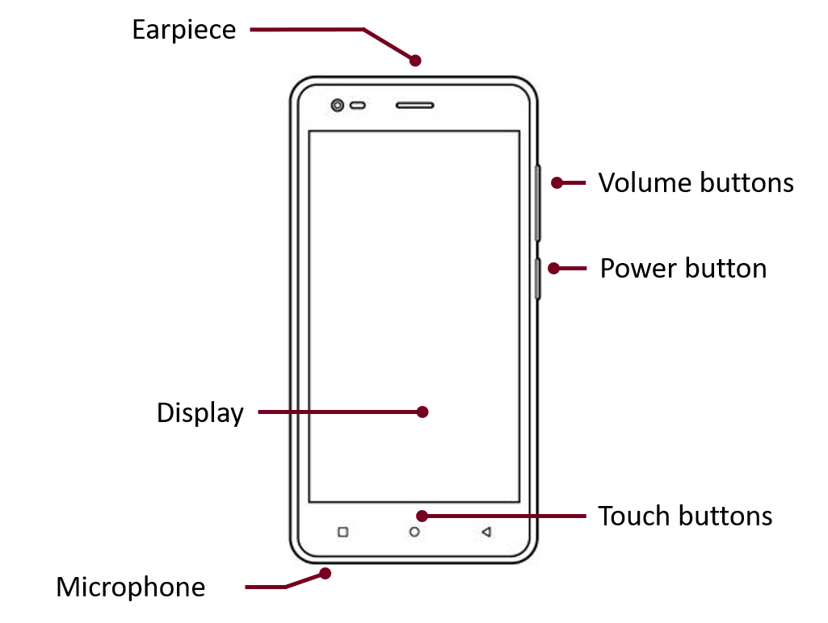

From the back view of your phone you will observe the following elements:

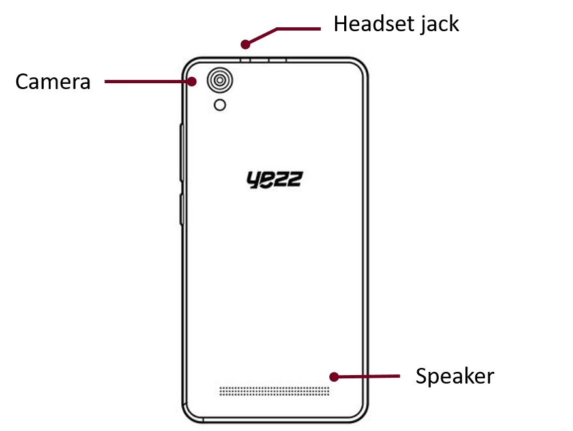

Keys

The following table offers you a quick description about the phone’s keys:

Key | Function
Power button | Allow you to turn on/off the device and to lock the screen.
Volume | Allow you to adjust the volume of ringing and notifications. Also allows you to adjust the volume of multimedia content playback.
Back | Allow you to return to the previous menu or screen. Also allow you to close some applications.
Home | It takes you directly to the home screen, leaving any application open.
Menu | Allow you to access to the functions menu of the application or screen you are.

Screen

The screen of your mobile phone is designed as follows:

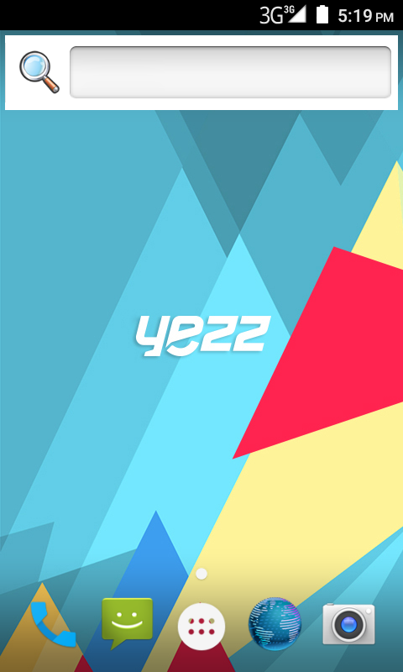

Icons

Learn about the icons that are displayed on the top of the screen, indicating the status of the phone:

 | Signal strength |  | Wi-Fi connection
 | Voice mail |  | EDGE connected
 | USB connected |  | HSPA connected
 | Battery meter |  | New message
 | Vibration profile |  | New email
 | Roaming indicator |  | Alarm active
 | Headset connected |  | Silent profile

PREPARING YOUR MOBILE PHONE

Get started setting up your mobile phone for its first use.

Install the SIM card and battery

When you subscribe to a cellular service, you will receive a Subscriber Identity Module (SIM) card, with subscription details, such as your personal identification number (PIN) and optional services.

To install the SIM card and battery,

1. Remove the battery cover.

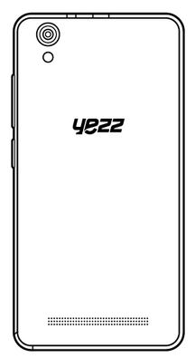
2. Insert the SIM card.

Your phone has 2 SIM card slots to allow you use 2 SIM cards and switch between them.

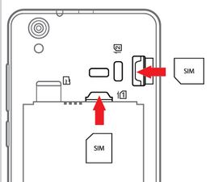

- Place the SIM card in the phone with the gold-colored contacts facing down.

- Without inserting a SIM card, you can use your phone’s non-network services and some menus.

3. Insert the battery.

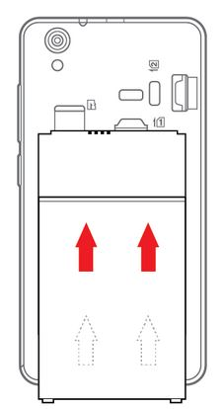

4. Replace the battery cover.

Insert a memory card (optional)

To store additional multimedia files, you must insert a memory card.

- Formatting the memory card on a PC may cause incompatibility with your phone. Format the memory card only on the phone.

1. Remove the battery cover.

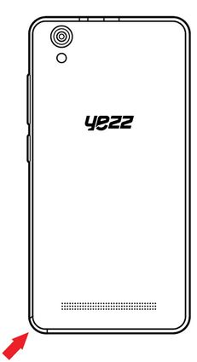

2. Insert a memory holder with the label side facing up.

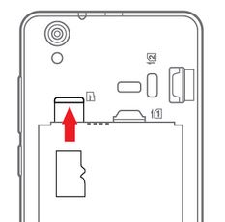

USING BASIC FUNCTIONS

Learn how to perform basic operations of your mobile phone.

Turn your phone on and off

To turn your phone on,

1. Long press the power button.

2. Type in your PIN number and press OK (if it is needed).

To shut down your phone, go to step 1 above.

Access menus and applications

To get access to the Menu and Applications,

1. At the home screen, touch the button  on the screen to pop up the list of Installed Applications in your phone.

2. Slide your finger to the right or left to access other pages of apps.

3. Touch any icon to enter to the application.

4. To exit the application, press Back or Home at the bottom of the screen.

Use basic call functions

Learn to make or answer calls in this section.
Make a call:

1. At the home screen or applications menu, touch the Phone icon  .

2. Dial the area code and phone number.

3. Touch  to start the call.

4. To end a call, touch .

To answer a call:

1. When you receive a call, slide the phone icon to the right to answer it or slide it to the left to reject it  .

2. To end the call, touch .

Send and view messages

In this section, learn how to send and receive:

- Text Messages (SMS).

- Multimedia Message (MMS).

Steps to send Text and Multimedia Messages:

1. Touch  Messages at the application list, then touch  on the corner.

2. Type in the phone number or contact name on the field or touch  to access to Contacts.

3. Type in your message.

To send as text message go to step 5.

To attach a multimedia object (audio, image, etc.) continue to step 4.

4. Touch  on the top right corner, select the attach type then choose the item.

5. Touch  to send the message.

Add contacts

Learn the basics of using the phonebook feature.

Add a new contact:

1. In the application list touch Contacts , then touch  on the bottom to add a new contact.

2. Fill the contact information (Name, Last name and phone number). You can add more fields such as, email, address.
3. Touch  on the top of the screen to save.

Search for a contact

1. In the application list touch Contacts.

2. Slide your finger from bottom to top to scroll the list or touch the search button  and type in the first letters of the name or last name.

3. To see the contact details touch the name or the picture of the contact.

If you want to call a contact touch the phone number.

Listen to music

Learn how to listen to music via the music player or FM radio.

Listen to the FM radio:

1. Plug in the earphones in your phone.

2. In the application list touch  FM Radio.

3. Use the tool bar at the bottom to change of station.

Listen to music files:

First, copy the music files into your phone internal memory or a MicroSD card.

1. In the application list, touch  Music.

2. Select an order at the top of the screen and touch the song that you want to listen to.

3. You can Pause, Loop, or change of song using the tool bar at the bottom.

Browse the web

Learn how to access to your favorites Web Sites.

1. In the application list, touch  Browser.

2. Touch the address bar and type in the address of the web site you want to go.

USING THE CAMERA

Learn the basics to capture and view photos.

Capture pictures

1. In the applications list, touch  Camera.

2. Adjusts the lens at the photo target and make the desired adjustments by touching the settings button .

3. Touch the shot button  on the screen to capture the picture. It will be saved automatically.

See the captured pictures

In the applications list, touch  Gallery and then select the Camera folder to access and visualize all the pictures captured by your phone.

CONNECTING TO INTERNET

Learn the basics to configure your phone and connect to Internet.

Add a new connection

1. In the applications list, touch  Settings to access to the device configuration.

2. Touch the option “More…”, then touch Mobile networks and touch Access Point Names. Now select the SIM Card that you want to configure.

3. Touch the Menu key and select New APN then, type in the parameters according with your Carrier.

The basic parameters are:

- Name
- APN
- Username
- Password

Some carriers use Proxy Servers, refer to your carrier configuration for more information.

4. When you finish typing in the parameters needed, touch Menu then Save.

If you have multiples APN Configurations for the same SIM card, choose which one you want to use touching the radio button  at the right side of the name.

To add another connection, repeat from step 3.

Switch between carriers
(SIM cards)

If you use multiple SIM cards and want to switch to another one, follow these steps:

1. In the applications list, touch Settings to access to the device configuration.

2. Touch .

3. Choose the option Data connection and select the SIM Card that you want to use.

USING THE Wi-Fi

Learn to use the phone's wireless capabilities to connect to any wireless local area network compatible.

Connect to a wireless network

1. In the applications list, touch Settings to access to the device configuration.

2. Touch the Wi-Fi option .

3. To turn the On the Wi-Fi touching the button  on the right top corner.

4. Choose a wireless network and enter the security password if it is needed.

Disconnect from a wireless network

1. In the applications list, touch Settings to access to the device configuration.

2. Touch the Wi-Fi option .

3. To turn the Wi-Fi off touch the button  on the right top corner.

View the technical details of a wireless network

1. In the applications list, touch Settings to access to the device configuration.

2. Touch the Wi-Fi option.

3. Touch the active wireless network to see details such as Link Speed, Signal strength and more.

